**PHP PROJECT REPORT**

**Submitted By**

**Chirag Maurya: A20405219021  
Jaideep Singh : A20405219047**

**Section: A**

**Semester: 4th**

**Course: B. Tech (C.S.E)**



**Submitted to**

**Dr. Abhay Sharma**

**Assistant Professor**

**Amity School of Engineering and Technology**

**Amity University Rajasthan**

Contents

CHAPTER 1 2

PROJECT SYNOPSIS 2

CHAPTER 2 3

WEBSITE LAYOUT 3

NAVIGATION BAR 3

FOOTER 4

HOME PAGE 4

CATALOGUE 5

TECH UPDATES 6

ABOUT US 8

LOG IN 9

CONTACT US 10

CATALOGUE SUMMARY 11

CHAPTER 3 12

WORKING OF THE WEBSITE 12

SCHEDULING OF REPAIRS 12

VIEWING THE CATALOGUE 15

CONTACT FORM 16

**TRUE FIX**

# CHAPTER 1

# PROJECT SYNOPSIS

This website will be on offering electronic repair services. It is based on an organization that offers repair services, both mobile and in-station services, depending on the work to be done. Some of the devices that are dealt with here are phones, laptops, watched, calculators, TVs, DVD players etc. Customers can call, email, book online appointments or visit the establishment physically to avail services from the organization. The website will contain all the details about the organization as well as the kinds of services they have offered. All customers will be registered to the website’s database either themselves through the online platform or by an attendant at the service station.

The pages that will be included are:

1. Homepage- contains all the basic information about the organization that existing and new customers need to know about
2. Catalogue- This page will contain details of some of the services that are offered by this organization with pictorial proof.
3. Log in page- this will allow customers to register themselves or access their accounts for active users. They will be a separate log in for staff members to access all information relevant to them such as tasks assigned to them.
4. Tech updates- This will be a page that will have interesting news being updated regularly related to technology to keep customers and clients interested and entertained.
5. Contact page- This will have all the information required to reach out to the organization.
6. About us- The page that contains information about what truefix is.

**Languages used**

This project has been developed by the implementation of three languages namely

* HTML- To create the basic page contents and such as texts, body contents, headers etc.
* CSS- To give a pleasing appearance to the general layout of the website
* PHP- Used in backend to link the website to database. It collects data input by the user and relates it to a database.

At some point a tiny script of Javascript has also been implemented to display alert messages.

 echo '<script type="text/javascript">alert("Log In successful")</script>';

echo '<script type="text/javascript">alert("Log In failed")</script>';

# CHAPTER 2

# WEBSITE LAYOUT

## NAVIGATION BAR

The navigation bar has 6 tabs that link to the 6 different pages.   
The active tab is colored green while the tab that is hovered over is colored black, hence indicating cursor position.



<ul style="display: inline;">

                <li class= "active"><a href="main.html">Home</a></li>

                <li><a href="catalogue.html">Catalogue</a></li>

                <li><a href="techupdates.html">Tech Updates</a></li>

                <li><a href="about.html">About Us</a></li>

                <li><a href="login.html">Log In</a></li>

                <li><a href="contactus.html">Contact Us</a></li>

             </ul>

li a:hover:not(.active){

    background-color: black;

}

.active{

    background-color: green;

}

.active a{

    background-color: green !important;

}

## FOOTER



<footer>

            <p>

                TRUEFIX PVT. LTD<br>

                E3450

            </p>

footer{

    text-align: center;

    background-color: #555;

    color: aliceblue;

    padding: 1px;

}

## HOME PAGE

The home page is the firs page of the website. It contains all the basic information about the organization that existing and new customers need to know about.

It has an option for scheduling which redirects the user to the Log In page where the user has to log in first and then schedule their repair.

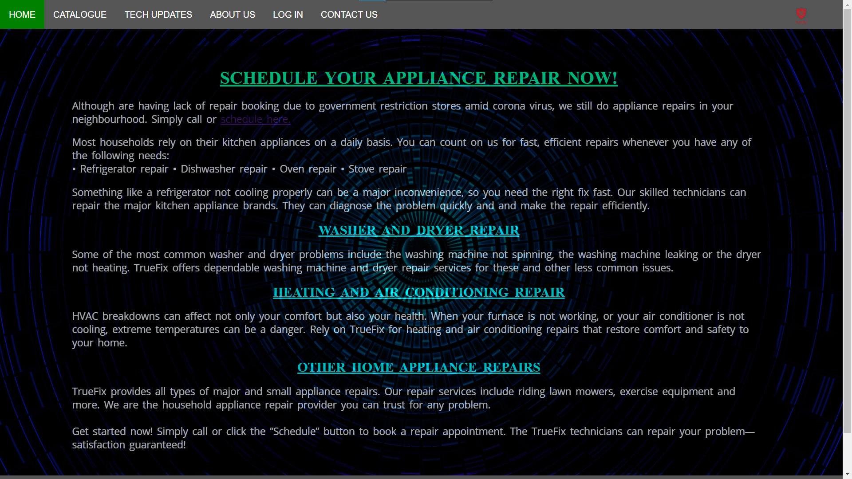

## CATALOGUE

The catalogue contains some of the line-ups of brands that truefix repairs. There is a wide range of brands and clicking on each brand opens a respective page that displays a little summary on what they do with those brands.



## TECH UPDATES

This page contains some tech news from all over the world. It allows the user to be up-to-date with the hottest tech news out there. They are just short summaries of the news to keep the user interested and increase website visits.

It can also act us a reference point for people doing research or writing essays related to tech as this will give them good content.

This page has photo and text arranged in alternating grid format.

<div class="two-column-wrapper">

                <div class='profile-image-wrapper'>

                    <img src="news/news7.jpg">

                </div>

                <div class="profile-content-wrapper">

                    <p>Consumers have filed a class action lawsuit against Sony alleging that the company is operating an unlawful monopoly by restricting purchases of PlayStation games to its in-house PlayStation Store. The consumers said that Sony charges "supercompetitive" prices for digital PlayStation games. People end up paying 175% more for downloadable games than the same ones on disk, they added.</p>

                </div>

            </div>

.portfolio-items-wrapper{

    display:grid;

    grid-template-columns: 1fr 1fr;

}

.portfolio-item-wrapper{

    position:relative;

}

.portfolio-image-background{

    height: 350px;

    width: 100%;

    background-size:cover;

    background-position: center;

    background-repeat: no-repeat;

    filter: brightness(50%);

}

.img-text-wrapper{

    position: absolute;

    top:0;

    display:flex;

    flex-direction: column;

    justify-content: centre;

    align-items: center;

    height: 100%;

    text-align: center;

    padding-left: 100px;

    padding-right:100px;

}

.logo-wrapper img{

    width:50%;

    margin-bottom: 10px;

}

.img-text-wrapper .subtitle{

    transition: 1s;

    font-weight:600;

    font-size: x-large;

    font-family: 'Courier New', Courier, monospace;

    color: transparent;

}

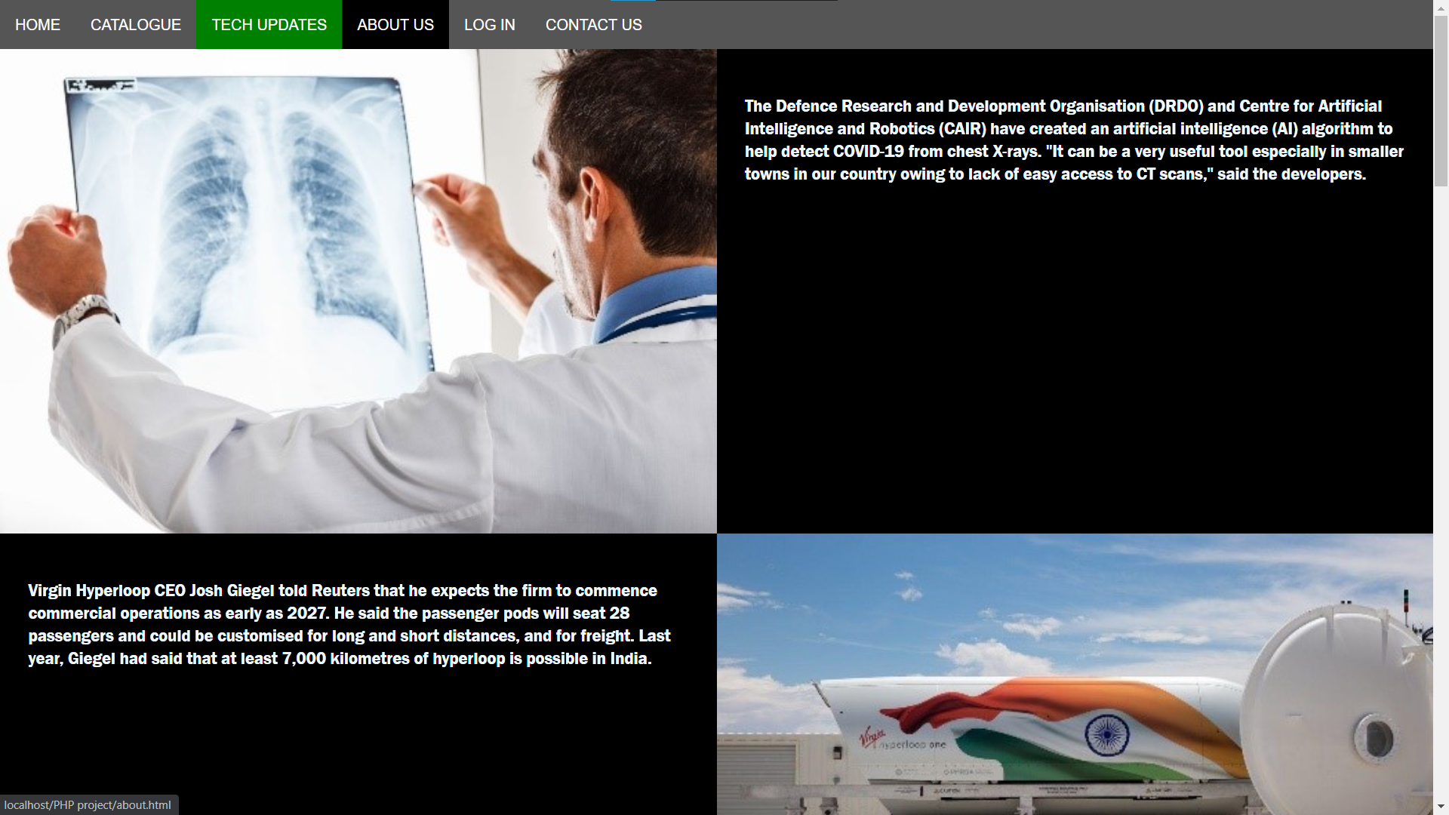

## ABOUT US

The page that contains information about what truefix is.

It has only an image and some text that describes the company.

<div class='content-wrapper'>

            <div class="two-column-wrapper">

                <div class='profile-image-wrapper'>

                    <img src="images/about.jpeg">

                </div>

                <div class="profile-content-wrapper">

                    <p>TrueFix is the leading appliance repair service in the nation. We repair most major appliance brands, makes and models, no matter where you bought them. Our goal is to provide quality repairs to help you extend the useful life of your household appliances.</br>

                        TrueFix is the only nationally authorized appliance repair service for Kenmore products. We have performed millions of GE appliance repairs on refrigerators, washers, dryers, ranges and more. Our technicians are appliance repair experts who you can trust for repairs on top appliance brands like Samsung, Maytag, Bosch, LG etc.</br>

                        Appliance service guarantee

                        TrueFix provides quality repair services to help extend the life of your appliances. We offer a 90-day satisfaction guarantee. If your appliance fails due to reasons related to the original repair, we will replace any parts that fail due to defects in materials, workmanship, and perform any additional labor free of charge.

                        We stand behind our work and the parts we use. Count on us for fast, reliable service and satisfaction guaranteed!</p>

                </div>

            </div>

            </div>

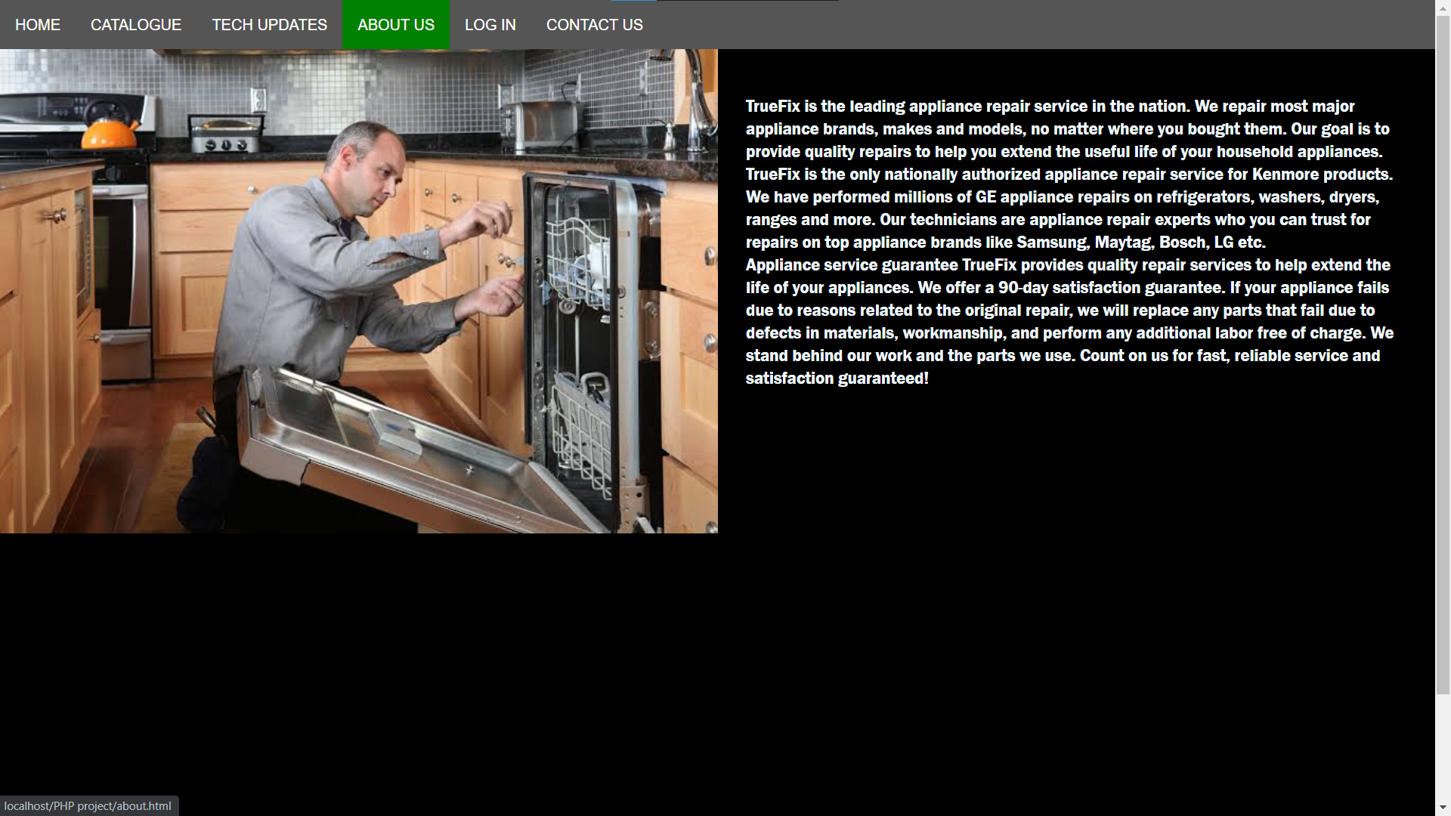

## LOG IN

This page allows the user to log in and schedule their repairs and get served with the comfort of staying at their remote places.

The form has only two text boxes that require ‘email’ and ‘password’.

All the fields must be filled for the data to be submitted else the user cannot proceed.

<form action="login.php" method="POST">

                    <h1>Login Page</h1>

                    <input type="email" name="email" class="txtbox" placeholder="Enter Email Id" required/><br><br>

                    <input type="password" name="password" class="txtbox" placeholder="Enter Password" required/><br><br>

                    <input type="submit" name="login" class="btn" value="LOGIN"/><br><br>

                    <input type="submit" name="back" class="btn" value="BACK"/>

                </form>

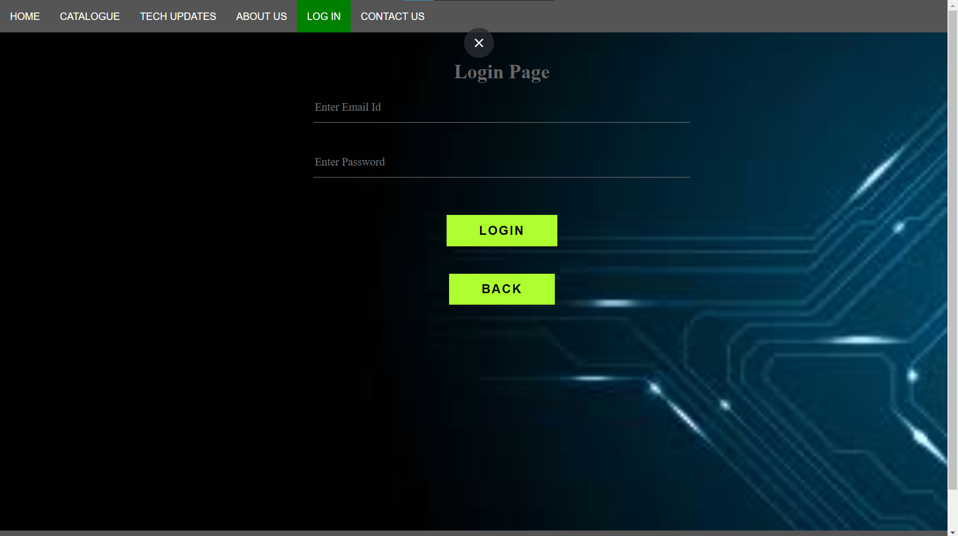

## CONTACT US

On this page the user can send an email via the form or get details of other contact options that they find more suitable.

Using this form they can send emails directly without necessarily having to use gmail.

 <form id="contact-form" method="POST" action="contactus.php">

                    <input name="name" type="text" class="form-control" placeholder="Your Name" required><br>

                    <input name="email" type="email" class="form-control" placeholder="Your Email" required><br>

                    <textarea name="message" class="form-control" placeholder="Message" row="4" required></textarea><br>

                    <input type="submit" class="submit" value="SEND MESSAGE">

                </form>

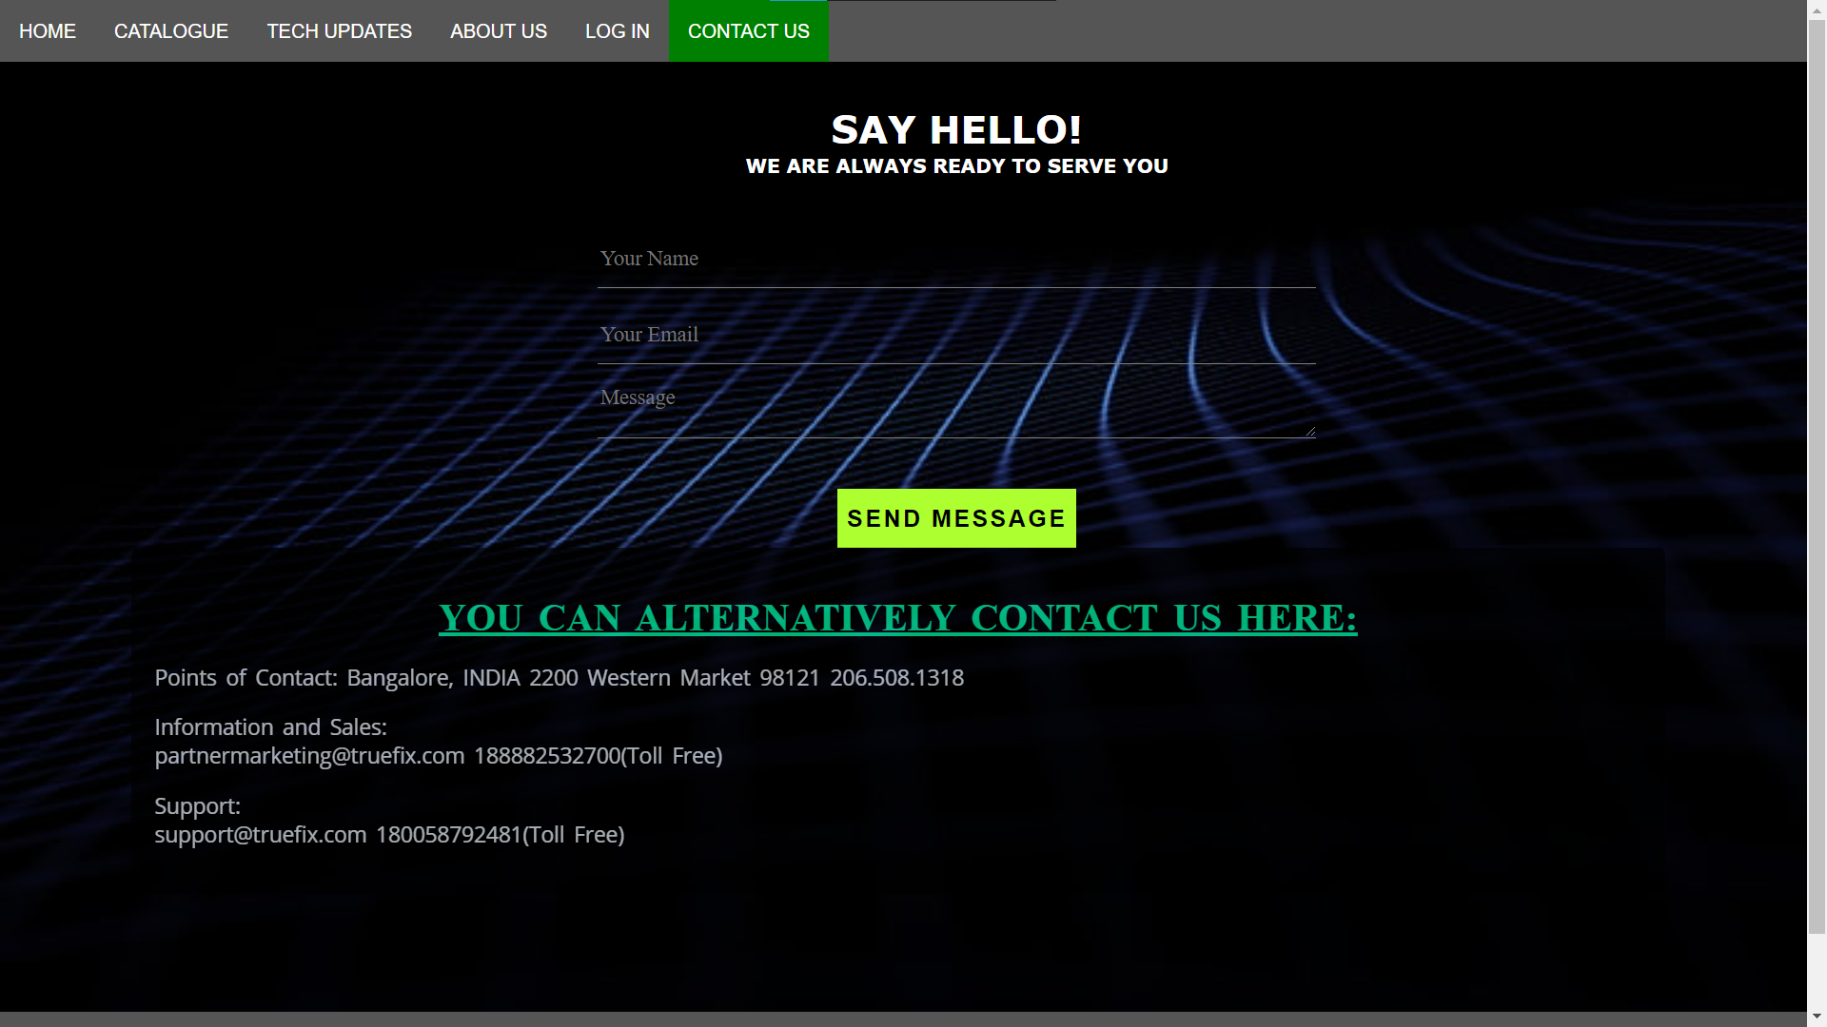

## CATALOGUE SUMMARY

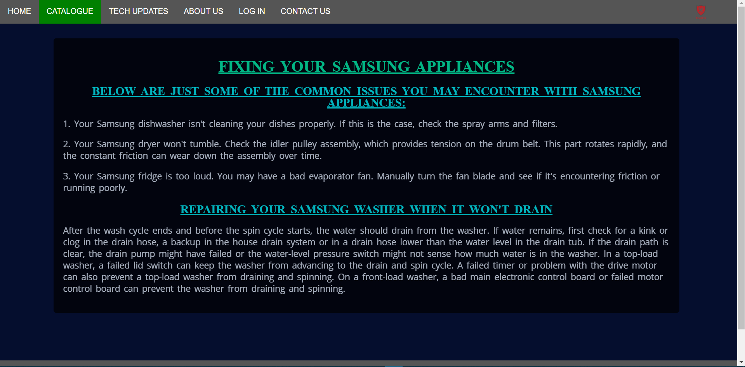

This is just a page that has article containing styled text.

 <main>

            <article>

                <h1>Fixing your Samsung appliances</h1>

                <h2>Below are just some of the common issues you may encounter with Samsung appliances:</h2>

                <p>1. Your Samsung dishwasher isn't cleaning your dishes properly. If this is the case, check the spray arms and filters.</p>

                <p>2. Your Samsung dryer won't tumble. Check the idler pulley assembly, which provides tension on the drum belt. This part rotates rapidly, and the constant friction can wear down the assembly over time.</p>

                <p>3. Your Samsung fridge is too loud. You may have a bad evaporator fan. Manually turn the fan blade and see if it's encountering friction or running poorly.</p>

                <h2>Repairing your Samsung washer when it won't drain</h2>

                <p>After the wash cycle ends and before the spin cycle starts, the water should drain from the washer. If water remains, first check for a kink or clog in the drain hose, a backup in the house drain system or in a drain hose lower than the water level in the drain tub. If the drain path is clear, the drain pump might have failed or the water-level pressure switch might not sense how much water is in the washer. In a top-load washer, a failed lid switch can keep the washer from advancing to the drain and spin cycle. A failed timer or problem with the drive motor can also prevent a top-load washer from draining and spinning. On a front-load washer, a bad main electronic control board or failed motor control board can prevent the washer from draining and spinning.</p>

            </article>

        </main>

The layout is the same for all other catalogue summaries.

# CHAPTER 3

# WORKING OF THE WEBSITE

This website has multiple redirections to multiple pages. Right from the homepage to the Log in page. It has been designed to be user friendly and be very simple to navigate through. The user can simply access all pages from the navigation bar

## SCHEDULING OF REPAIRS

The user that uses the website is definitely there seeking for repair services hence there is a link that guides him to schedule right there and then in just a click.



Once the user clicks on ‘schedule here’ he/she is redirected to the log in page to proceed. The user first needs to login first then be able to schedule a repair. This enables the details to be verified first.

<p>

                Although are having lack of repair booking due to government restriction stores amid corona virus, we still do appliance repairs in your neighbourhood. Simply call or <a href="login.html">schedule here.</a>

            </p>

The embedded link is in the body that redirects the user to the login page.

Once n the login page, if the user enters correct details then login is successful and he/she is redirected to the scheduling page.

if(isset($_POST['login'])){

      $email = $_POST['email'];

      $password = $_POST['password'];

      $query="select * from login WHERE email='$email' AND password='$password'";

      $query_run = mysqli_query($connection,$query) or die(mysqli_error($connection));

      if(mysqli_fetch_array($query_run,MYSQLI_BOTH)>0){

          echo '<script type="text/javascript">alert("Log In successful")</script>';

          header('Location:schedule.html');

      }

      else{

        echo '<script type="text/javascript">alert("Log In failed")</script>';

      }

  }

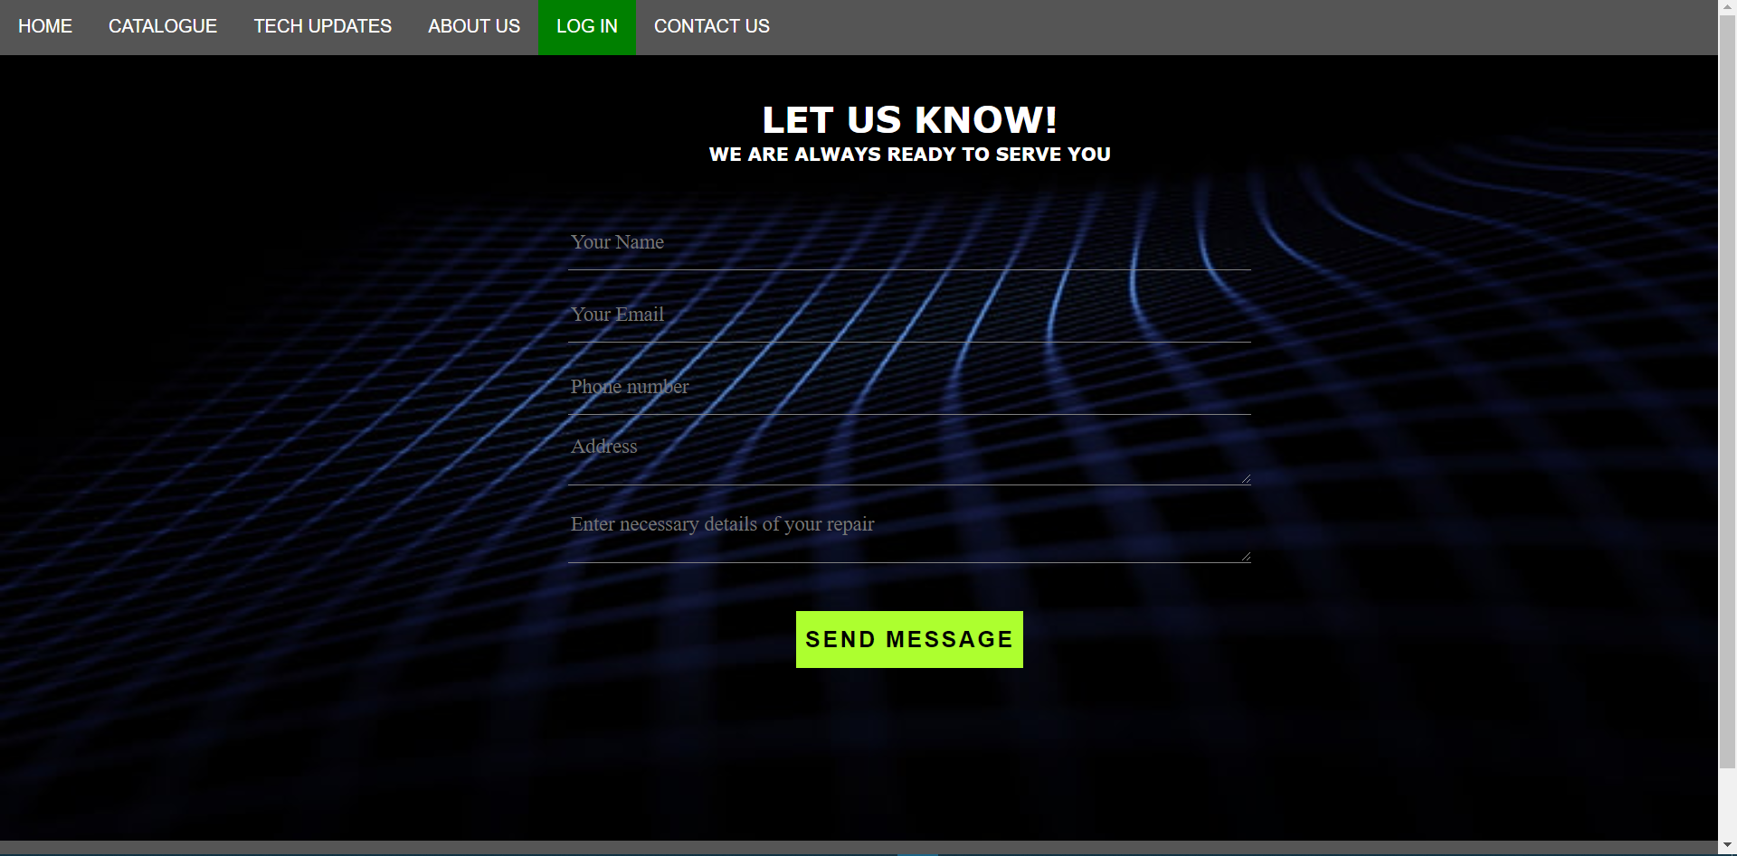

The schedule form takes in 5 parameters that are all required then the user can proceed to send the message.

<form id="contact-form" method="POST" action="schedule.php">

                    <input name="name" type="text" class="form-control" placeholder="Your Name" required><br>

                    <input name="email" type="email" class="form-control" placeholder="Your Email" required><br>

                    <input name="phone" type="number" class="form-control" placeholder="Phone number" required><br>

                    <textarea name="Address" class="form-control" placeholder="Address" row="4" required></textarea><br>

                    <textarea name="message" class="form-control" placeholder="Enter necessary details of your repair" row="50" required></textarea><br>

The styling has been done the same as the contact form hence same classes have been used.

Once the details are filled and the button is clicked, then the email is sent to the company.

$email_from="mauryachurag114@gmail.com";

    $email_subject="New Form Submission";

    $email_body="User Name: $name.\n".

                "User Email:$visitor_email.\n".

                "User Phone:$phone.\n".

                "User address:$address.\n".

                "User Message: $message.\n";

    $to="mauryachirag7468@gmail.com";

    $headers= "From: $email_from\r\n";

    $headers= "Reply-To: $visitor_email\r\n";

    mail($to,$email_subject,$email_body,$headers);

If the user enters the wrong the credentials, then a ‘Fail’ message is displayed.

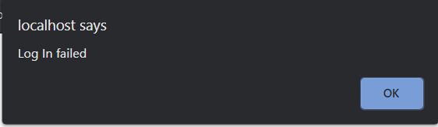

## VIEWING THE CATALOGUE

When the user clicks on any logo a catalogue summary is opened that tells the user on what the company does of such brands.

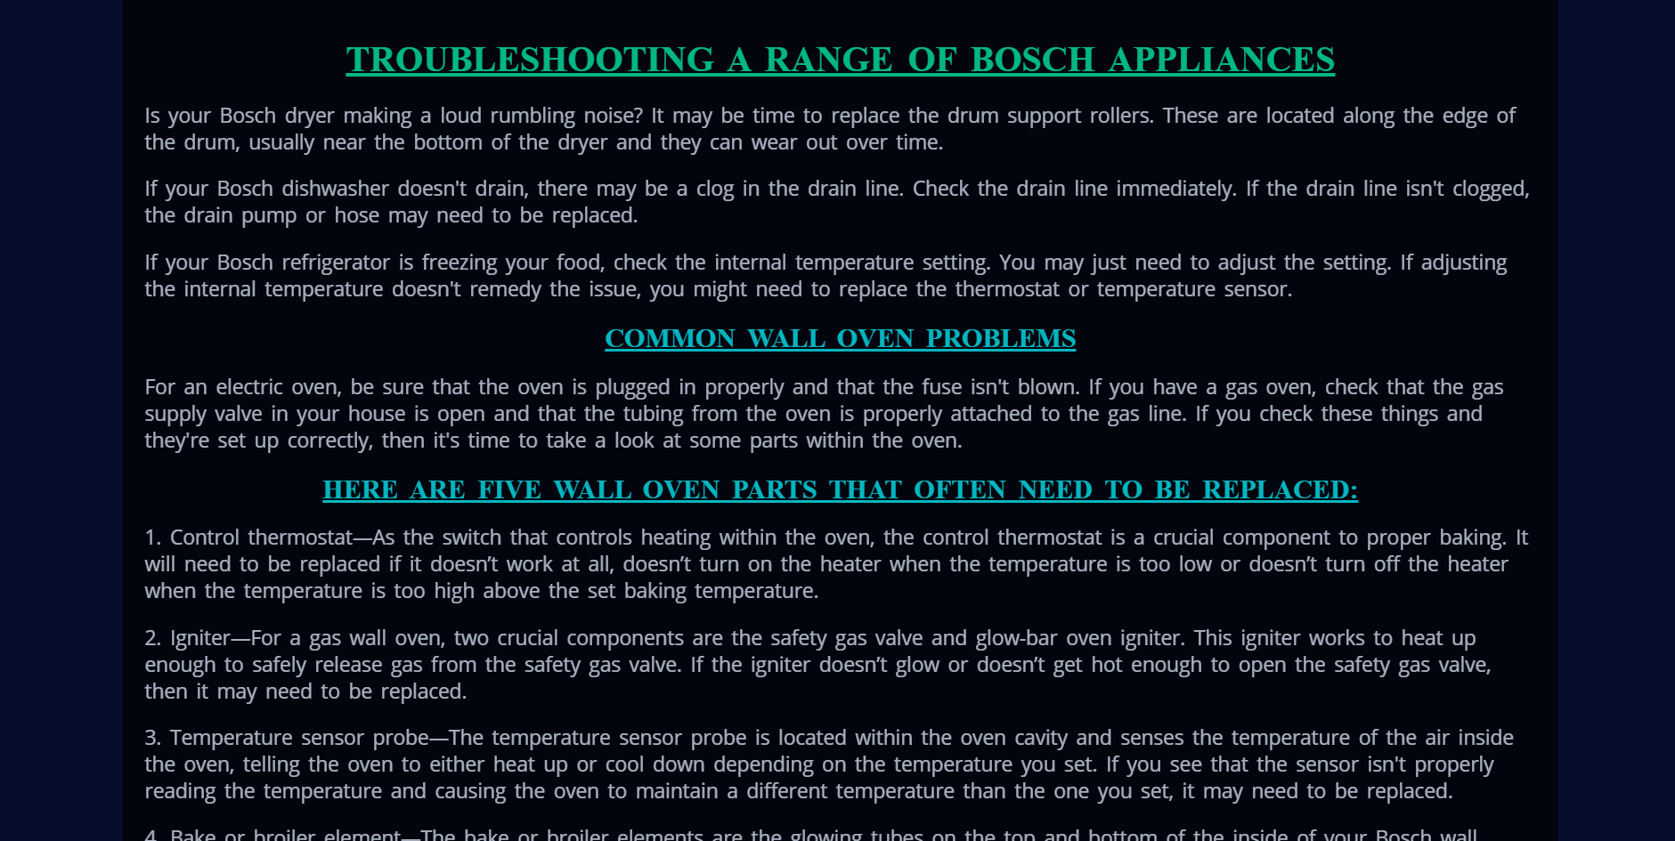

The user is redirected to another page which contains the summary of the respective brands.

 <a href="LG.html"> <img src="pics/lg.png">

This happens for every brand mentioned in the catalogue.

## CONTACT FORM

All the user has to do is to fill in the details and a message and the email will be sent to the company.

$email_from="mauryachurag114@gmail.com";

    $email_subject="New Form Submission";

    $email_body="User Name: $name.\n".

                "User Email:$visitor_email.\n".

                "User Message: $message.\n";

    $to="mauryachirag7468@gmail.com";

    $headers= "From: $email_from\r\n";

    $headers= "Reply-To: $visitor_email\r\n";

    mail($to,$email_subject,$email_body,$headers);

The above code is the back-end functioning of the contact form.